# About Us

TMHM is a career-oriented platform which envisions ameliorating your skills by providing you with career set-up programs to explore and compete with the competitive world. We offer various courses related to business, web designing, marketing, development and much more. We make the process easy going for students and job seekers who are willing to explore all the career paths and transform their hidden talents and skills into their profession. We work for the betterment and growth of the newly joined employees in the corporate world by training them in personality development, soft skills and overall professional growth.

Our mission is ‘to bring talent to limelight’. We want each and everyone to explore their inner talents and lead a successful life.

We also provide parent-child counseling and psychometric assessment which will help you catch up with the ongoing scenario. We are looking forward to helping you in admissions and placements, campus branding and enhancing credibility.

We wish to achieve milestones with you. Our team members are committed to support you.

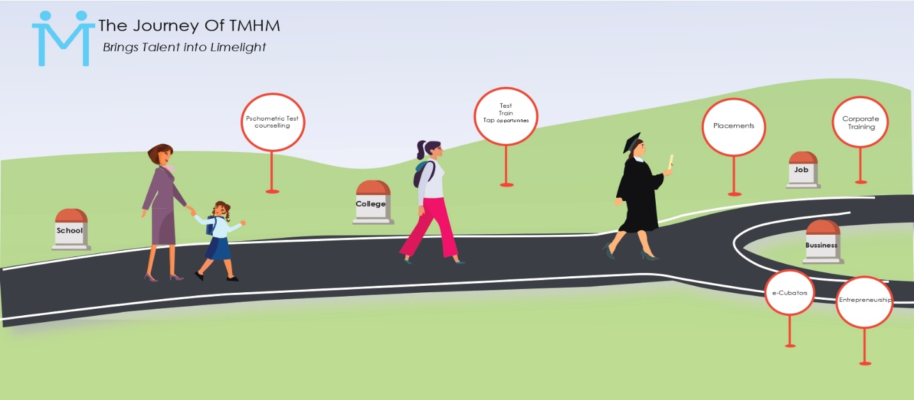

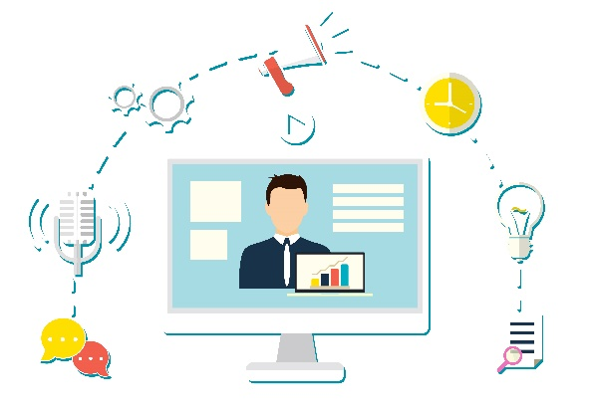   ONLINE COURSES

 LEARNERS

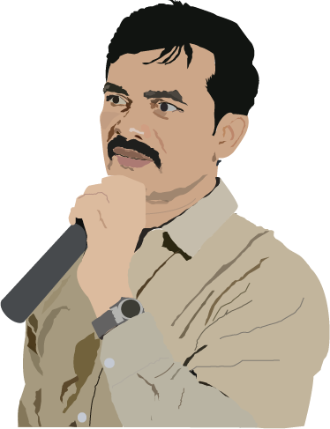 FACILITATORS

 SELF PACE LEARNING

 PROTRUDE FOR A BETTER FUTURE

PROCURE AN INTERNSHIP